**Code:**

<!DOCTYPE html>

<html>

<head>

<title>Find the area</title>

</head>

<body>

<h1>Area of triangle using Javascript</h1>

<label>Enter length of Side 1 of triangle =</label>

<input type="number" id="side1"><br><br>

<label>Enter length of Side 2 of triangle -</label>

<input type="number" id="side2"><br><br>

<label>Enter length of Side 3 of triangle </label>

<input type="number" id="side3"><br><br>

<button type="button" id="areatri">Submit</button>

<p>AREA OF TRIANGLE: <span id="display"></span></p>

<script>

document.getElementById("areatri").onclick = function() {

var side1 = parseInt(document.getElementById("side1").value);

var side2 = parseInt(document.getElementById("side2").value);

var side3 = parseInt(document.getElementById("side3").value);

var s = (side1 + side2 + side3) / 2;

var area = Math.sqrt(s * (s - side1) * (s - side2) * (s - side3)).toFixed(2);

document.getElementById("display").innerHTML = area;

}

</script>

<h1>Area of Rectangle using Javascript</h1>

<label>Enter length of rectangle -</label>

<input type="number" id="len"><br><br>

<label>Enter breadth of rectangle</label>

<input type="number" id="bre"><br><br>

<button type="button" id="arearec">Submit</button>

<p>AREA OF RECTANGLE: <span id="display1"></span></p>

<script>

document.getElementById("arearec").onclick = function() {

var len = parseInt(document.getElementById("len").value);

var bre = parseInt(document.getElementById("bre").value);

var area = (len * bre).toFixed(2);

document.getElementById("display1").innerHTML = area;

}

</script>

<h1>Area of Circle using JavaScript</h1>

<label>Enter radius of Circle =</label>

<input type="number" id="rad"><br><br>

<button type="button" id="areacir">Submit</button>

<p>AREA OF CIRCLE: <span id="display2"></span></p>

<script>

document.getElementById("areacir").onclick = function() {

var rad = parseInt(document.getElementById("rad").value);

var area = (3.14 * rad * rad).toFixed(2);

document.getElementById("display2").innerHTML = area;

}

</script>

</body>

</html>

**Output**

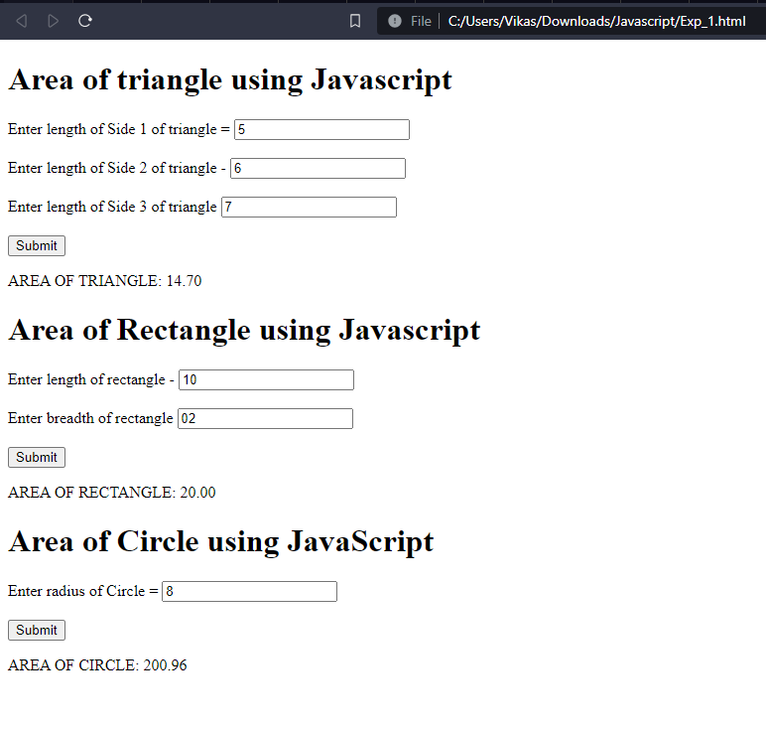

**Code:**

<!DOCTYPE html>

<html>

<head>

<title>Multiplication table of 2</title>

</head>

<body>

<h1>Multiplication table of 2</h1>

<script>

// Define the number for which you want to create the multiplication table

const number = 2;

// Create a multiplication table for the number

for (let i = 1; i <= 10; i++) {

// Multiply i with the number

const result = i * number;

// Display the result in the console

console.log(number + " * " + i + " = " + result);

// Display the result on the web page

document.write("<p>" + number + " * " + i + " = " + result + "</p>");

}

</script>

</body>

</html>

**Output:**

**Code**

<!DOCTYPE html>

<html>

<body>

<h2>JavaScript String Methods</h2>

<p>Replace all occurrences of "Microsoft" with "W3Schools" in the paragraph below: </p>

<button onclick="myFunction()">Try it</button>

<p id="demo">Microsoft is a freemium educational website for learning coding online. Initially released in 1998.

Microsoft offers courses covering all aspects of web development.<br>

Microsoft also publishes free HTML templates.

Microsoft is run by Refsnes Data in Norway.<br>

Microsoft has an online text editor called TryIt Editor, and readers can edit

examples

and run the code in a test environment.</p>

<script>

function myFunction() {

let text = document.getElementById("demo").innerHTML;

document.getElementById("demo").innerHTML =

text.replace(/Microsoft/g, "W3Schools");

}

</script>

</body>

</html>

**Output**

**Code**

<!DOCTYPE html>

<html>

<body>

<h3>Compare Strings</h3>

Enter String 1: <input id="string1"><br>

Enter String 2: <input id="string2"><br>

<button onclick="comp1(); comp2(); comp3();">Compare</button>

<script>

function comp1() {

// Using toUpperCase()

var string1 = document.getElementById("string1").value;

var string2 = document.getElementById("string2").value;

// Compare both strings

const result = string1.toUpperCase() === string2.toUpperCase();

console.log("Using toUpperCase()");

if (result) {

console.log('The strings are similar.');

} else {

console.log('The strings are not similar.');

}

}

function comp2() {

// Using RegEx

var string1 = document.getElementById('string1').value;

var string2 = document.getElementById("string2").value;

// Create a regex pattern

const pattern = new RegExp(string1, "gi");

// Compare the strings

const result = pattern.test(string2);

console.log("Using RegEx");

if (result) {

console.log('The strings are similar.');

} else {

console.log('The strings are not similar.');

}

}

function comp3() {

// Using localeCompare()

var string1 = document.getElementById("string1").value;

var string2 = document.getElementById("string2").value;

const result = string1.localeCompare(string2, undefined, { sensitivity: 'base' });

console.log("Using localeCompare()");

if (result === 0) {

console.log('The strings are similar.');

} else {

console.log('The strings are not similar.');

}

}

</script>

</body>

</html>

**Output**

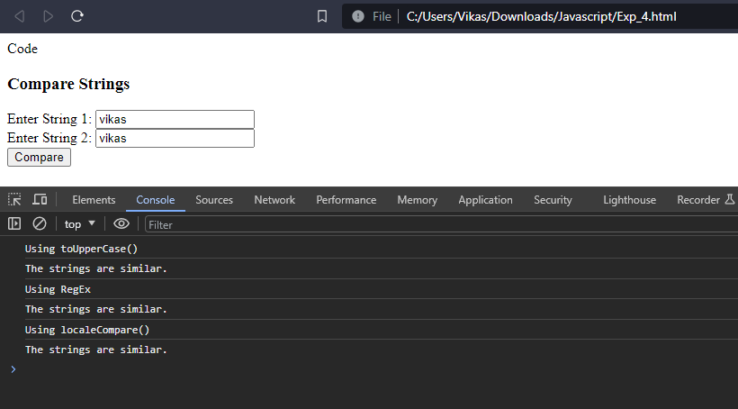

**Code**

<!DOCTYPE html>

<html>

<body>

<h2>String</h2>

<button onclick="RevStr()">Reverse a String</button>

<button onclick="Rep1Chr()">Replace Characters</button>

<p id="test"></p>

<p id="demo">My Music with Microsoft Apps</p>

<script>

function Rep1Chr() {

document.getElementById("test").innerHTML = "Replace all occurrences of M with W in the paragraph: My Music with Microsoft Apps";

let text = document.getElementById("demo").innerHTML;

document.getElementById("demo").innerHTML = text.replace(/M/g, "W");

}

function RevStr() {

// Empty string

let revString = "";

let str = prompt("Enter a String:");

for (let i = str.length - 1; i >= 0; i--) {

revString += str[i];

}

console.log("Given String: " + str + "<br>Reversed String: " + revString);

PalStr(str, revString);

}

function PalStr(str, revString) {

// Compare the original and reversed strings

if (str === revString) {

console.log('It is a palindrome');

} else {

console.log('It is not a palindrome');

}

}

</script>

</body>

</html>

**Output**

**Code**

<!DOCTYPE html>

<html>

<body>

<h3>Building Countdown Timer Using Date Function</h3>

<p id="demo"></p>

<script>

// Set the date we're counting down to

var tDate = new Date();

document.write("<br>" + "Today's Date is: " + tDate);

document.write("<br>" + "Month is: " + tDate.getMonth());

document.write("<br>" + "Day is: " + tDate.getDate());

document.write("<br>" + "Time is: " + tDate.getTime() + " msec");

var tt = tDate.getTime();

var countDownDate = new Date("Jan 5, 2024 15:37:25").getTime();

var diff = countDownDate - tt;

document.write('<br>' + "Time in msec from 1 Jan 1970 till Jan 5, 2024 is: " + countDownDate);

document.write("<br>" + "Difference: " + diff);

// Update the countdown every 1 second

var x = setInterval(myTimer, 1000);

function myTimer() {

// Get today's date and time

var now = new Date().getTime();

// Find the distance between now and the countdown date

var distance = countDownDate - now;

// Time calculations for days, hours, minutes, and seconds

var days = Math.floor(distance / (1000 * 60 * 60 * 24));

var hours = Math.floor((distance % (1000 * 60 * 60 * 24)) / (1000 * 60 * 60));

var minutes = Math.floor((distance % (1000 * 60 * 60)) / (1000 * 60));

var seconds = Math.floor((distance % (1000 * 60)) / 1000);

// Display the result in the element with id="demo"

document.getElementById("demo").innerHTML = days + "d " + hours + "h " + minutes + "m " + seconds + "s ";

// If the countdown is finished, write some text

if (distance < 0) {

clearInterval(x);

document.getElementById("demo").innerHTML = "EXPIRED";

}

}

</script>

</body>

</html>

**Output**

**Code**

<!DOCTYPE html>

<html>

<body>

<h3>Demonstrate Array Operations</h3>

<button onclick="removeElement()">Remove Element</button>

<button onclick="chkValue()">Check Value</button>

<button onclick="emptyArray()">Empty Array</button>

<script>

function removeElement() {

var shoeBrand = ["Nike", "Adidas", "Sparks", "RedTape"];

console.log("Elements in array before removing: " + shoeBrand);

// Removing the last element from the array

var poppedElement = shoeBrand.pop();

console.log("Removed last element from array using pop(): " + poppedElement);

// Display the remaining elements present in the array after removing

console.log("New array: " + shoeBrand);

// Removing 2 elements from position "1"

shoeBrand.splice(1, 2);

console.log("Removed elements from array using splice(1, 2):\nNew Array: " + shoeBrand);

}

function chkValue() {

var carBrand = ["Maruti", "BMW", "Kia"];

console.log(carBrand);

var str = prompt("Enter carBrand Value");

const hasValue = carBrand.includes(str);

console.log(carBrand);

console.log("Value entered: " + str);

// Check the condition

if (hasValue) {

console.log('Array contains: ' + str);

} else {

console.log("Array does not contain: " + str);

}

}

function emptyArray() {

var carBrand = ["Maruti", "BMW", "Kia", "Tata"];

console.log(carBrand);

carBrand.splice(0, carBrand.length);

console.log("Empty Array: " + carBrand);

}

</script>

</body>

</html>

**Output**

**Code**

<!DOCTYPE html>

<html>

<head>

<h2>Demonstrate Set Operations</h2>

<p>Set A: {'apple', 'mango', 'orange'}</p>

<p>Set B: {'grapes', 'apple', 'banana'}</p>

<p>Set C: {'apple', 'orange'}</p>

<button onclick="union()">Union of Sets</button>

<button onclick="intersection()">Intersection of Sets</button>

<button onclick="difference()">Difference of Sets</button>

<button onclick="subset()">Subset of Set</button>

</head>

<body>

<script>

// Two sets of fruits

const setA = new Set(['apple', 'mango', 'orange']);

const setB = new Set(['grapes', 'apple', 'banana']);

const setC = new Set(['apple', 'orange']);

function union() {

let unionSet = new Set(setA);

for (let i of setB) {

unionSet.add(i);

}

console.log(unionSet);

}

function intersection() {

let intersectionSet = new Set();

for (let i of setB) {

if (setA.has(i)) {

intersectionSet.add(i);

}

}

console.log(intersectionSet);

}

function difference() {

let differenceSet = new Set(setA);

for (let i of setB) {

differenceSet.delete(i);

}

console.log(differenceSet);

}

function subset() {

for (let i of setC) {

if (!setA.has(i)) {

console.log(false);

return;

}}

console.log(true);

}

</script>

</body>

</html>

**Output**

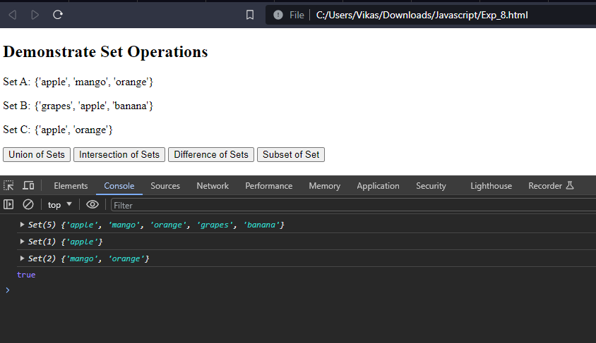

**Code**

<!DOCTYPE html>

<html>

<body>

<h2>Demonstrate mouseover() and focusFunction()</h2>

<h3 id="demo" onmouseover="mouseover()" onmouseout="mouseout()">Mouse over me</h3>

<input type="text" placeholder="Enter Text" id="focus" onfocus="focusFunction()" onblur="blurFunction()">

<script>

function mouseover() {

document.getElementById("demo").style.color = "red";

}

function mouseout() {

document.getElementById("demo").style.color = "black";

}

function focusFunction() {

document.getElementById("focus").style.background = "yellow";

}

function blurFunction() {

document.getElementById("focus").style.background = "red";

}

</script>

</body>

</html>

**Output**

**Code**

<!DOCTYPE html>

<html>

<body>

<input id="text1" placeholder="Enter Number">

<input id="text2" placeholder="Enter Number">

<br>

<button onclick="sum()" id="btn">Add</button>

<button onclick="diff()" id="btn">Subtract</button>

<button onclick="mult()" id="btn">Multiply</button>

<button onclick="div()" id="btn">Divide</button>

<input id="result" placeholder="Result">

<script>

function sum() {

var x = parseFloat(document.getElementById("text1").value);

var y = parseFloat(document.getElementById("text2").value);

var result = x + y;

document.getElementById("result").value = result;

alert(result);

}

function diff() {

var x = parseFloat(document.getElementById("text1").value);

var y = parseFloat(document.getElementById("text2").value);

var result = x - y;

document.getElementById("result").value = result;

alert(result);

}

function mult() {

var x = parseFloat(document.getElementById("text1").value);

var y = parseFloat(document.getElementById("text2").value);

var result = x * y;

document.getElementById("result").value = result;

alert(result);

}

function div() {

var x = parseFloat(document.getElementById("text1").value);

var y = parseFloat(document.getElementById("text2").value);

var result = x / y;

document.getElementById("result").value = result;

alert(result);

}

</script>

</body>

</html>

**Output**

